Refugees Originating from Sudan
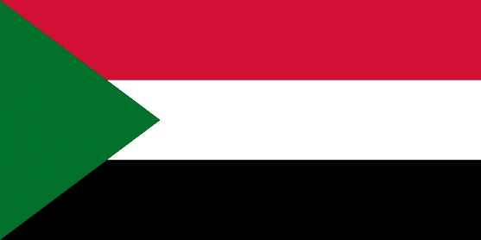
Ethnic Groups: Sudan has 500+ ethnic groups; 70% Arab majority and numerous non-Arab minorities such as the Masalit, Zaghawa, Fulani, Northern Nubians, Nuba, and Beja. Refugees from Sudan in the U.S. are from the minority ethnic groups.
Primary Language: Sudanese Arabic (approximately 70 languages and hundreds of dialects are native to Sudan; some do not have a written alphabet)
Primary Religion: Islam (97%)

Holidays with the same date every year: January 1 Independence Day, January 7 Coptic Christmas, June 30 Revolution Day, and December 25 Christmas Day
Holidays with variable dates: Al-Mowlid Al Nabawi (Birth of the Prophet), Eid al-Fitr (End of Ramadan), Islamic New Year, Eid al-Adha (Feast Of Sacrifice), and Coptic Easter - Islamic holidays are fixed to the Islamic calendar which follows the phases of the moon, therefore every year holidays will be 10 to 11 days earlier in our (U.S.A.) Gregorian calendar. Furthermore, Islamic holidays depend on the sighting of the moon.

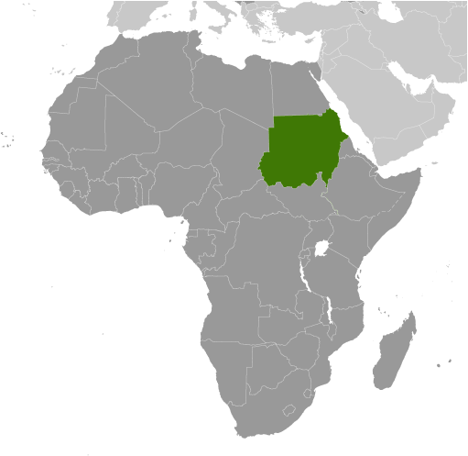
Historical Background
- Sudan, once the largest and one of the most geographically diverse states in Africa, split into two countries (Sudan and South Sudan) in July 2011 after the people of the south voted for independence.
- Decades of conflict had existed between the two regions for religious, economic, and political reasons.
- The north is majority Muslim while the south is majority Christian and Animist.
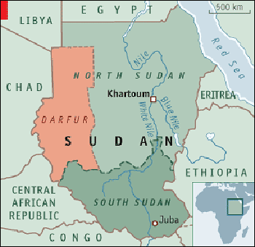
- When Sudan gained its independence from colonizers in 1956, it was with the understanding that the southerners would be able to participate fully in the political system. When the Arab Muslim government reneged on its promises, a mutiny began that led to two prolonged periods of conflict (1955-1972 and 1983-2005) in which perhaps 2.5 million people died - mostly civilians.
- Disputes still remain between South Sudan and Sudan such as sharing of the oil revenues, as an estimated 80% of the oil is in South Sudan but they lack the necessary infrastructure to monetize this resource.
- A separate conflict, which broke out in the western region of Darfur in 2003, has displaced nearly two million people and caused an estimated 200,000 to 400,000 deaths. Violence in Darfur in 2013 resulted in an additional estimated 6,000 civilians killed and 500,000 displaced.
- Countries where refugees tend to flee initially: Egypt, Chad, Kenya, Ethiopia

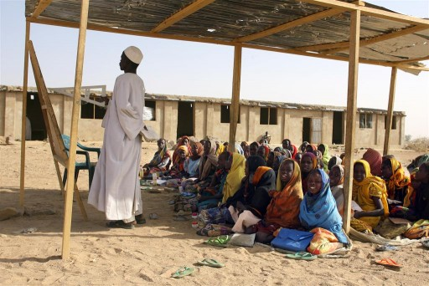
Academic Considerations
Education in Sudan is free and compulsory for children aged 6 to 13 years, although more than 40% of children are not going to schools. Primary education consists of eight years, followed by three years of secondary education. The primary language at all levels is Arabic. Schools are concentrated in urban areas; many in the west (Darfur region) have been damaged or destroyed by years of civil war. The literacy rate is 70.2% of total population, male: 79.6%, female: 60.8%. Note, Arabic is read right to left as opposed to English which is left to right.
One of the five daily prayers of Islam is mid-day; U.S. schools should accommodate this at parent’s request.

Naming Standards
Arabic naming convention is as follows: [personal name], [father’s first name], [grandfather’s first name] whether the child is male or female. Note, this may not involve the use of a surname. In some cases, people may use a “Family Name”. The family name would be related to tribe, a trait, or a profession. Family names quite often starts with “Al” which is the Arabic definite article (the). Women do not change their name when married. People are usually addressed by their first name - except for elders, teachers, lawyers and religious leaders who are addressed by their respective title.

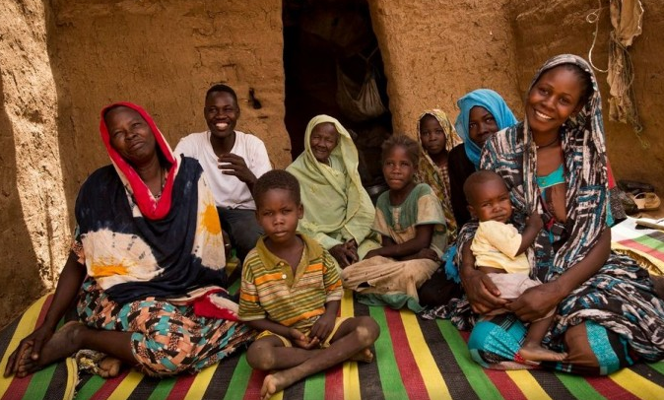
Family Engagement
Stand to greet people, especially those that are older than you. The common greeting between relatives and people of the same gender is to tap each other’s left shoulder with the right hand before shaking hands and taking a step back. This is repeated a few times. Some Sudanese may also give warm hugs depending on the relationship. People generally do not touch those of the opposite gender during greetings unless they are related. The correct way to greet a large group is to lift your right hand up and announce “Salam”. Expect some greetings to be quite prolonged. People often shake hands multiple times, ask many questions and express their gratitude to see you.

- Use your right hand or both hands together to gesture or offer anything. The left hand is used for cleaning and hygiene purposes and should not be used to gesture or touch food/people.
- Avoid eating, drinking or smoking in front of a Muslim during the fasting month of Ramadan.
- It is rude to show, point, or expose the soles of feet your feet to a Sudanese or Muslim person whilst sitting.
- Offer services or items multiple times. If you only offer something once, a Sudanese person may decline out of politeness even though they meant to accept on the second offer.
- Be careful when you compliment an item in a Sudanese person’s house, as they may feel compelled to offer it to you as a gift. If they try to give it to you, insist that you appreciate their gesture but do not want to take it.
- It is very important to accept any refreshment (typically coffee/tea) as a mark of friendship.
- Remove your shoes when entering someone’s home unless advised otherwise.
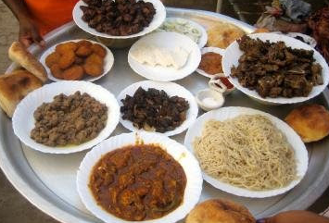
- Dogs are considered unclean in Sudan (and Islam) and are not meant to be let into areas where people pray (i.e. homes). Let them know in advance if dogs will be present.

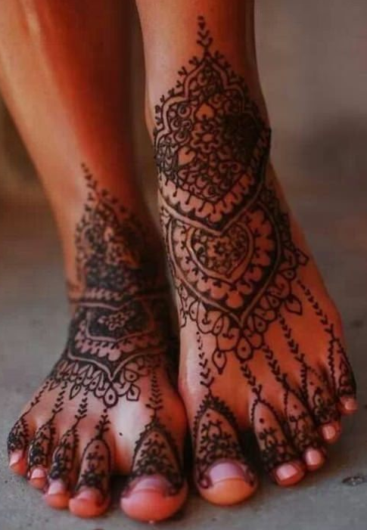
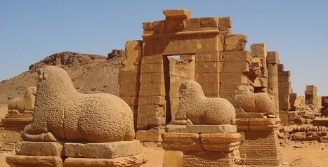
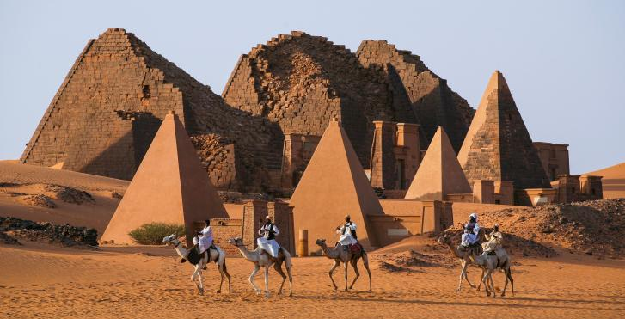
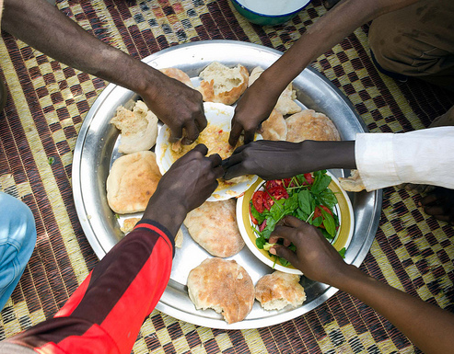
Plates are shared and food is eaten with the right hand.

Henna designs are traditionally done for celebrations, such as weddings

The area of the Nile valley known as Nubia, which lies within present day Sudan, was home to three Kushite kingdoms during antiquity.
255 pyramids have been discovered in Sudan.

