I-485 Application to Register Permanent Residence or Adjust Status (Green Card)
Checklist for Refugees

Please Note: This is your last chance to correct a date of birth. If an I-94 has the wrong date of birth and the applicant has supporting evidence of the correct date, include a copy of the supporting evidence along with a letter stating the situation and request to correct.
- All refugees are required to adjust their status to LPR after one year in the U.S. regardless of age
- There is no filing fee for refugees
- Must complete and submit the USCIS form I-485
  - Form I-693 (the “clinic envelope”) can be submitted at the same time or later, but must be completed eventually. Usually the Civil Surgeon gives an extra copy to the applicant, so you only need to submit the sealed envelope – everything needed by USCIS is inside.
I-94
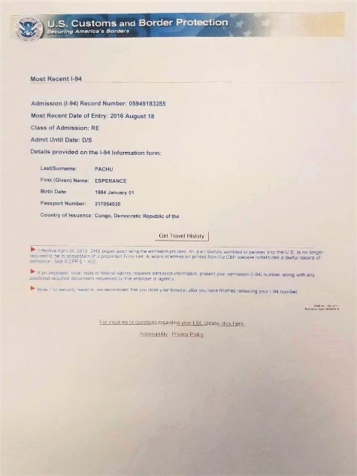
Please bring:
- Passport photos for all applicants
- I-94
- Boarding Letter

Please be prepared to answer ALL of these questions:

- Full legal name
- Social security number
- Phone number
- Your city and country of birth
- City you entered the U.S.A. through (airport arrival)
- All addresses and dates of residency in the U.S.A.
- Last address outside of the U.S.A.
- Name, address, and dates of all employment in U.S.A.
- Height
- Weight
- Information about your parents
  - Full names
Boarding Letter
  - Dates of birth (if known)
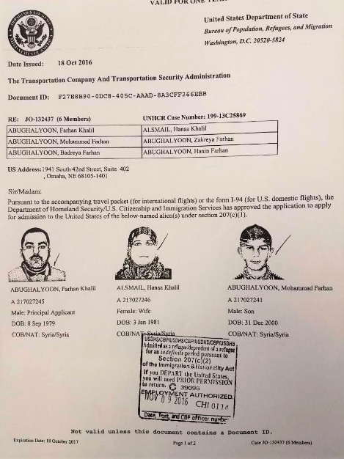
  - Places of birth
  - Current city and country (if alive)
- Information about all husbands or wives (living, dead, or divorced)
  - Full name
  - Date of birth

  - Alien number
  - Place of birth
  - Place of marriage
  - Date of marriage
  - Date marriage ended

- Information about all living children
  - Full name
  - Date of birth
  - Place of birth
  - Alien number

