Omaha Public Schools
ESL, Migrant, and Refugee Programs

Understanding Our School System:
A Guide for Immigrant Families
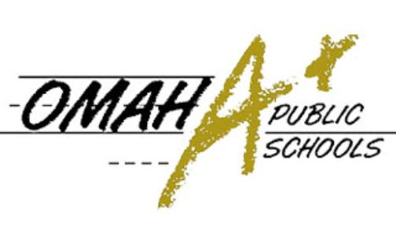
Table of Contents
Education in the United States Pages 2-5
Student Code of Conduct Page 6
Nebraska Attendance Policy Page 7
OPS ESL Advantage Placement Chart Page 8
High School Graduation – Credits Needed Page 9-10
Higher Education (College and University) Page 11
Alternative Opportunities for Students 18-21 Years of Age Page 12
Adult Education and ESL Page 13
Acknowledgement of Receipt Page 14

Your school bilingual liaison contact information:

Name: __________________________________________________________

Phone Number: ___________________________________________________

www.ops.org
Education in the United States
* Some excerpts taken from USCIS’ Welcome to the United States: A Guide for New Immigrants

To ensure all children are prepared to succeed, the United States provides free public education from kindergarten through grade 12 for all students. This section tells you how to enroll your children in school, how schools in the United States work, and how to help your children learn.
Enroll Your Child in School
You can send your child to a public or private school. Public schools are free and do not offer religious instruction. The state decides what your child learns in public school, but local school districts, principals, teachers, and parents decide how to teach your child. Your taxes help pay for public schools.
Private schools are owned and run by groups that are independent of the government, including religious and non-religious groups. Students generally must pay a fee (called tuition) to attend private school. Some private schools are coeducational, while some are only for boys or only for girls. To learn more about private schools, contact your state’s Department of Education.
Most American children are in public school for around 13 years, from kindergarten through grade 12. In most schools, your child will be placed in a class (called a grade) based on two things: age and level of previous education. In some cases, a school may give your child a test to determine his or her grade level and class assignment.
How most Nebraska schools are structured:

Preschool | Ages 3-5 years
Elementary (Primary) Schools | Ages 5-12 years (kindergarten through 4th, 5th or 6th grades depending upon school)
Middle or Junior High Schools | Ages 12-14 years (5th-8th grades depending upon school)
High (Secondary) Schools | Ages 14-21 years (9th-12th grades)
Higher Education – College, University, or Trade Schools | Upon completion of high school

What will my child learn?
Each state sets their own academic standards for schools. These standards outline what students should know and at what level they are expected to perform. Local school districts decide how this information should be taught. Most schools teach English, math, social studies, science, and physical education. Art, music, and foreign languages are sometimes offered, too.

How long are school years and days?
In Nebraska, the school year usually begins in August and ends in May. Extra summer school is available if needed. Children are in school Monday through Friday. Elementary school is from 8:50am-4:05pm. Middle and High school is from 7:40am-3:05pm. It is very important your child is on time to school! Many schools offer Kids Club programs before or after regular school hours for elementary school children whose parents work. You may be charged a fee for Kids Club, but financial assistance is available through the DHHS Title XX program if you meet the income eligibility.

What documents do I need to enroll my child?
- Birth certificate or I-94
- Proof of address
- DHHS master case number if you are applying for free or reduced lunch
- Immunization record – and possibly a health physical, depending upon your child’s age
- If your child has special developmental or medical needs please bring supporting evidence
If you do not have health insurance or cannot afford the immunizations needed to keep your child in school, OPS has School-Based Health Centers where your child can receive healthcare on a sliding fee scale. Please ask school staff for more information.

What if my child does not speak English?
All new K-12 families enrolling in an OPS school will complete a Home Language Survey to identify students who speak a language other than English. Students who have been identified with another language will be given an assessment to evaluate their knowledge of the English language. After testing is completed, the parent or guardian is notified of the results and English as a Second Language (ESL) services may be offered. ESL teachers design lessons to foster students' ability to read, write, speak, and understand academic English. Once the student qualifies for ESL services, they will be tested every year to monitor progress.

ESL is different than Dual Language programming. Dual language is a form of bilingual education in which students are taught literacy and content in two languages. In OPS Dual Language classes students are taught in both English and Spanish – half of the content is in English, half is in Spanish.

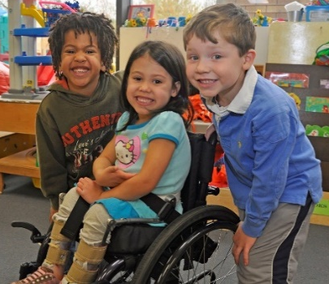
What if my child has a disability?
All students in the United States have the right to a free public education, whether or not they have a disability. If your child has special developmental or medical needs please bring supporting evidence, such as former school documentation or medical records. Your child may receive free special education and related services. You can participate when school staff make individualized decisions about how to best teach your child. The school is responsible for communicating with you about these decisions in a language that you can understand.

How long can my child attend public school?
In Nebraska, students can attend public school for free until they graduate high school or reach the maximum of age 21. If a student has not graduated from high school by age 22, there are alternative paths through which they can pursue an education. Ask your child’s school guidance counselor or bilingual liaison to learn more about these alternatives.

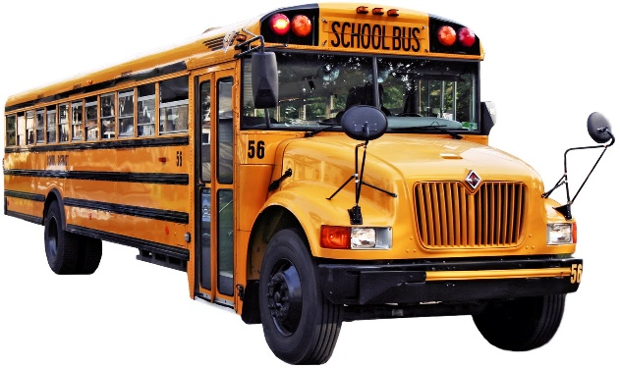
How will my child get to school?
School bus transportation is not guaranteed.
It depends upon the distance you live from your child’s school. Our transportation guidelines are:
Elementary School | 1 mile
Middle School | 1.5 miles
High School | 3 miles

If you live less than the designated distance from school, you are expected to walk or transport your own child. City bus passes may be provided in some cases; ask your bilingual liaison about this option if you do not qualify for a school bus. You could also set up a car pool with other parents in your area to share driving or walking the children to school. OPS Transportation phone number: 531-299-0140
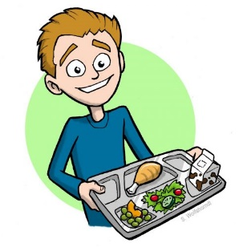
What will my child eat at school?
Children can take food to school (talk to your school staff about what is allowed) or buy it at the school cafeteria. The U.S. government provides free or low-cost breakfast and lunch for eligible children who cannot afford to buy food at school. Talk with school staff to find out if your children are eligible to receive free or reduced fee meals.

Who pays for books and school activities?
Public schools provide free textbooks. Books must be well cared for by your child and returned to the school when finished using for class. Do not write in or damage school books. Students usually buy their own school supplies, such as paper, pencils, and backpacks. If you cannot pay for these supplies, contact your child’s school. Assistance may be available.
Some schools may charge a small fee for special events, such as school trips. Many schools offer after-school sports and music programs. You may need to pay a fee for your child to participate in some of these programs. These are optional programs, not compulsory.
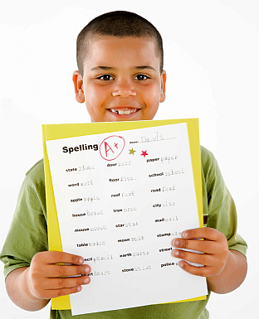
How is my child’s work assessed?
Teachers assign scores (also called grades) based on student’s work throughout the school year. Grades are usually based on homework, classwork, and tests. Your child will receive a report card several times a year. A report card tells you how your child is doing in each subject. Schools have different ways of grading students. OPS kindergarten-2nd grade use Advanced, Proficient, Basic, Below Basic, and Beginning to summarize your student’s performance. 3rd-12th grades use letters, with A or A+ for excellent work and D or F for poor or failing work. Ask school staff to explain how students in your child’s school are graded and assessed.

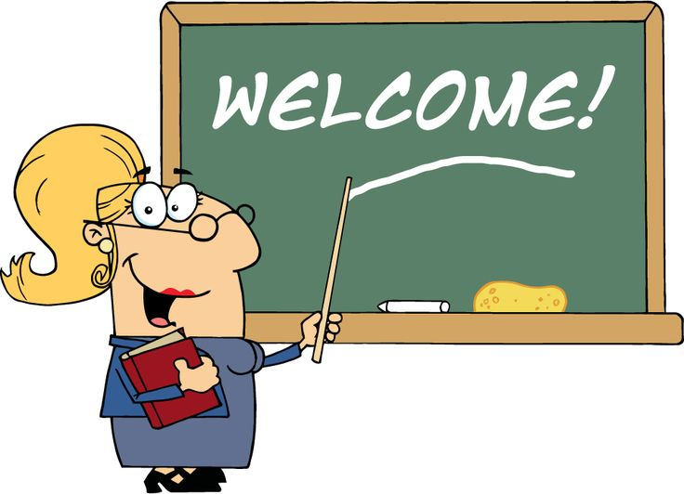
How can I talk to my child’s teacher?
Most schools have regular parent conferences for you to meet with your child’s teacher. You can also schedule meetings to talk with teachers or school administrators about how your child is doing in school any time you have questions. If you do not speak or understand English, the school district will provide a qualified interpreter for such meetings. The school district is required to provide you with information on other school matters in a language you understand.
Most public and private schools have a Parent Teacher Association (PTA) or Parent Teacher Organization (PTO) that you may join. These groups help parents learn about what is going on in their child’s school and how to get involved in events. At most schools, anyone can join, even grandparents. You can get involved even if you do not speak or understand English. Many schools have information specifically for parents with limited English skills. Let the school know that you will need interpreter services so that you can participate. Call or visit your child’s school office to find out when the PTA/PTO meets and how you can join. You can also talk to your child’s teacher and ask if there are other ways that you can volunteer or get involved.

What if my child gets into trouble?
Many schools have a list of rules or a discipline policy that students must obey, often called a Code of Conduct. Ask your child’s school about its discipline policy or code of conduct. The school may discipline students who break school rules by requiring them to stay after the school day is over or by banning them from participating in sports or other school activities. Physical punishment is not permitted in U.S. schools. Schools will report the behavior issue to the parent or guardian and expect the issue to be addressed at home.
- Detention – Staying late after school; supervised by school staff.
- In-school suspension – Not allowed in their classrooms for a number of days; supervised by staff in a separate area of the school.
- Suspension – Student is not allowed to attend school for a number of days; supervised by parents or guardians at home. Students must make up their school work.
- Expulsion – No longer allowed to attend the same school. You will need to meet with school staff to find out how to get your child into a different school.
Generalized Student Code of Conduct
Please reference your full school code of conduct book for more detailed information.
- Attend school daily and ON TIME
- No cell phone use in school - must be silenced and left in your child’s locker during the day
- No smoking anywhere on school property, even outside (students and adults)
- No betelnut on school property (students and adults)
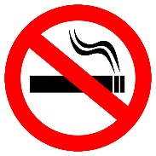
- No medication on school property without a doctor’s note. Must be given to school nurse.
- No sexual harassment – no inappropriate/sexual comments or touching; sexual harassment is illegal and victims have a right to press criminal charges
- No weapons – guns, knives, or brass knuckles of any size can result in expulsion
- No foul language or name calling

If your child is being bullied or harassed at school, please let us know so we can try to help.

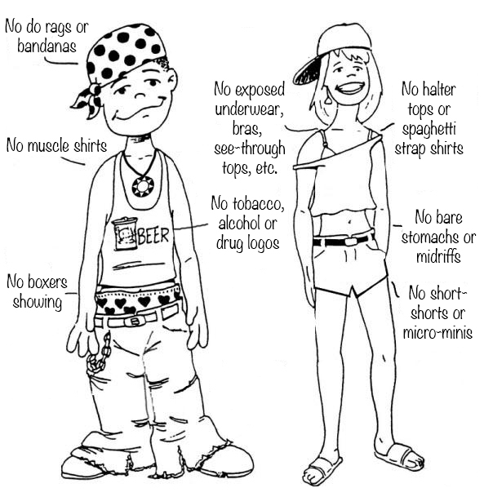
Dress appropriately:
- No references to drugs, alcohol, or foul language
- Modest dress; no “spaghetti straps”, nothing see-through or too revealing such as very short shorts and skirts
- No gang related clothing or jewelry
- No colored bandanas
- No belt buckles or jewelry that look like weapons
- No sagging pants (underwear should not show)
- Hoods and hats cannot be worn indoors (hijab is OK)
- Pay attention to weather changes. Your child needs to be dressed warmly during winter months – socks, underwear, long pants or skirts, thick coats, gloves, hats, and good shoes or boots.
- No sandals or flip flops in cold weather
- Depending on your child’s age and class schedule, they may need certain clothes for Physical Education class

If you need help clothing your family appropriately please ask your school for assistance.

If your child rides a school bus, certain behaviors are expected:
- Be at the stop ON TIME – the bus will not wait for you
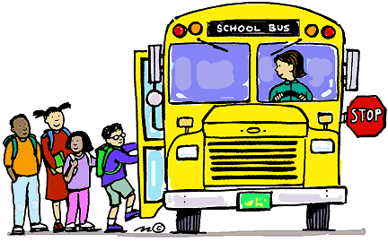
- Sit down and sit still – no standing when the bus is in motion
- No open food or drink on the bus
- No smoking
- No foul language
- No inappropriate or sexual touching
- No fighting or yelling
- Do not open the windows without permission from the driver
- Hands, arms, heads must stay inside the windows at all times
- Do not leave trash on the bus or throw trash out the window

School Attendance Policy
Nebraska Law: It is mandatory for children between the ages of 6 and 18 to attend school. Parent/s or guardian must make sure their child attends school regularly. It is the parent’s legal responsibility; it is not a choice.

The only exceptions to the law are:
- If the student has already obtained a high school diploma
- If the student has reached the age of 16 and the parents/guardians request an exit interview with the school to discuss valid reasons to withdraw their child.
Valid reasons to withdraw a student over age 16 are limited to:
  - Financial hardships requiring the child to work in order to support their family.
  - An illness of the child making attendance impossible or impractical.

Legal Consequences:
If a child misses 20 days of school per year without excuse, then a referral can be made to the County Attorney. Depending upon the circumstances, consequences may differ. In most cases, referrals to social services are made. Participation in these services is mandatory. Your family may be assigned a case worker to work with you individually, or your child may be required to join certain programs (like drug treatment).

In some cases, your family may be required to go to court. Do NOT miss your court date. Missing your court date only makes the legal problems worse. In court, a judge decides what the consequences of breaking the law will be for your family. Consequences can be very serious.
Some examples of serious consequences are:
- Probation
- The parent may be charged with negligence
- The child may be removed from the home

If a student has turned 18 and chooses to drop out of school (which is NOT recommended), then the family needs to actively dis-enroll that child from school. You cannot just quit attending; you must sign the proper paperwork.

If your child has a valid reason to miss school, you must call the school or your bilingual liaison first thing in the morning and let them know why!

Examples of accepted excused absences are:
- School sponsored activities
- Bereavement (attending a funeral)
- Court/Legal appearance
- Sick and/or medically excused (a doctor’s note is required for long term absence)
- Religious holiday
- Suspension
Advantage Placement Guide for English Language Learners
Advantage placement is most applicable for students entering a formal education system for the first time.

2017-2018 school year sample:
 | Standard Placement |  | Advantage Placement
Date of Birth | 01/01 - 07/31 | 08/01 – 12/31 | 01/01 - 07/31 | 08/01 – 12/31
2011 | Kindergarten
2010 | 1st grade | Kindergarten | Kindergarten
2009 | 2nd grade | 1st grade | 1st grade | 1st grade
2008 | 3rd grade | 2nd grade | 2nd grade | 2nd grade
2007 | 4th grade | 3rd grade | 3rd grade | 3rd grade
2006 | 5th grade | 4th grade | 4th grade | 3rd grade
2005 | 6th grade | 5th grade | 5th grade | 4th grade
2004 | 7th grade | 6th grade | 6th grade | 5th grade
2003 | 8th grade | 7th grade | 7th grade | 6th grade
2002 | 9th grade | 8th grade | 8th grade | 7th grade
2001 | Dependent upon transfer credits | 9th grade | 9th grade | 8th grade
2000 - 1996 | Dependent upon transfer credits

Credits Needed to Graduate High School

High school graduation is not dependent upon age, years spent in school, or grade level. Students need to pass required classes to graduate high school.
Each class that a student passes earns the student a credit.
If you have them, please bring any previous school records from overseas.
Credits may transfer from previous studies.
You need 49 credits to graduate from an OPS high school:
English | 8 credits
Math | 6 credits
Social Studies | 7 credits
Science | 6 credits
Physical Education (PE) | 4 credits
Human Growth and Development | 1 credits
Electives (ESL classes count as electives) | 17 credits
Total | 49

ESL students usually need extra time to finish all the required credits.
Here is a typical ESL high school graduation plan (based on 2017-2018 school year):

Year 1
Block/Period | Day A or Periods 1-4 | Day B or Periods 5-8
1 | ESL 1  ESL 2 | ESL 1  ESL 2
2 | ESL Reading 1  ESL Reading 2 | ESL Reading 1  ESL Reading 2
3 | Math (level depends on ability)  Option: ESL Math Prep 1-2 (not a math credit) | Physical Education (PE)
4 | ESL Social Studies Found 1  ESL Social Studies Found 2 | ESL Science Found 1  ESL Science Found 2
June Summer School: Math Essentials 1-2 (earns math credit) or ESL 1-2 Enrichment

Year 2
Block/Period | Day A or Periods 1-4 | Day B or Periods 5-8
1 | ESL 3  ESL 4 | ESL 3  ESL 4
2 | ESL Reading 3  ESL Reading 4 | ESL Reading 3  ESL Reading 4
3 | Math (level depends on ability) | P.E.
4 | ESL Social Studies Found 3 (one semester)  Geography (one semester) | ESL Science Found 3  ESL Science Found 4
June Summer School: Economics / TBD

Year 3
Block/Period | Day A or Periods 1-4 | Day B or Periods 5-8
1 | ESL Reading 5  ESL Reading 6 | English 1 ELL  English 2 ELL
2 | World Language | Economics (one semester)  Human Growth (one semester)
3 | Math (level depends on student’s ability) | Elective (Academic Literacy or Speech recommended)
4 | US History (ELL) | Physical Science
June Summer School: English 3-4

Year 4
Block/Period | Day A or Periods 1-4 | Day B or Periods 5-8
1 | English 5-6 | English 7-8
2 | World Language / Elective | Science Course (Chemistry for University bound)
3 | Math (level depends on student’s ability) | Science Course (Biology)
4 | Am. Government / Financial Literacy | World History

OPS high schools on a block schedule are: Benson, Bryan, and Burke.
OPS high schools on a 9 period day schedule are: Central, Northwest, and South.

Students should talk to their guidance counselor to ensure they are on a path that will earn them the credits needed to graduate. For example, students planning to attend a four year university will need additional math credits than those listed in the above credit path. Guidance Counselors are in schools to offer students advice on academic and sometimes personal matters. Students can also talk to counselors about applying for college and scholarships.

Students can be involved in clubs like THRIVE or sports. www.facebook.com/OPSTHRIVE/
School clubs and sports provide a positive social environment for your child. Not only will they develop leadership and/or athletic skills, spending time in a supervised environment will keep them out of trouble on the streets while the parent or guardian is at work.

“Late” school buses are available if you receive school transportation. Talk to your school office or bilingual liaison to learn more about how to use the “late” bus system.

Additional free resources in your school building:
- School nurse
- After school tutoring
- Social worker to assist with problems in the home, like:
  - Family fighting
  - Housing
  - Food shortage

Additional OPS District Support Programs:
- Migrant Education 531-299-9582
- Homeless Education 531-299-9635

For other helpful information in common refugee languages, please visit:
www.omaharefugees.com

For translated video instructions on how to ride the city bus, please visit:
https://www.youtube.com/channel/UCZWfCY2zEYGEDCFygP4MMyA/videos

For translated video instructions on how to use Omaha Public Libraries, please visit:
https://omahalibrary.org/welcome-to-the-library-video/

Higher Education – Colleges and Universities

After high school, people can continue their education in a two-year community or technical college, a four-year college, or a university. These are called postsecondary institutions or institutions of higher education. Typically, the first four years of postsecondary education is called undergraduate education, and schooling beyond the bachelor’s degree is called graduate studies. There are both public and private institutions of higher education. Generally, public colleges and universities may cost less than private ones, especially for residents of the state where the college or university is located. Adults can also choose to attend schools to learn how to do specific jobs, such as repairing computers or being a health care assistant. Students in higher education choose a specific subject to study in depth (this subject is called their major).
Degree Type | School | Length of Study
Certificate or License | Community College/Trade School | 6 months to 2 years
Associate’s Degree | Community College | 2 years
Bachelor’s Degree | 4 Year College or University | 4 years
Master’s | University | 2 years
Doctorate | University | 2-8 years
Professional | Specialized School | 2-5 years

College or university education can be expensive, but there are programs to help you pay for the cost of education. Visit your school’s financial aid office to learn about different ways to cover the cost.

Federal Financial Aid for College Students (FAFSA)
Federal financial aid can help cover expenses such as tuition, fees, room and board, book supplies, and transportation. Students generally qualify for this aid based on their financial need, not their grades. There are three types of federal aid:
- Grants: money that you do not have to repay
- Work study: money that you earn by working while you are in school
- Loans: money that you borrow now but must repay later with interest
For more information on federal financial aid programs, call 1-800-433-3243 or visit the U.S. Department of Education website at www.StudentAid.ed.gov/resources.

Beware of Financial Aid Fraud! (Scams)
Be careful when you are searching for information about student financial assistance. Avoid offers that seem too good to be true or that promise you results in exchange for money. Every year, families lose millions of dollars to scholarship fraud. If you are the victim of fraud or for more information, call the Federal Trade Commission at 1-877-382-4357. You can also visit their website at www.consumer.ftc.gov/articles/0082-scholarship-and-financial-aid-scams.

Alternative Educational Opportunities for Students 18-21 Years of Age
Who May Age Out Before Graduating High School

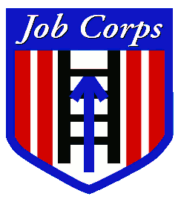
Job Corps
www.jobcorps.gov
4521 Leavenworth St, Omaha, NE 68106
(402) 926-2810
- Ages 16-24
- High school diploma
- Job training
- Driver’s license

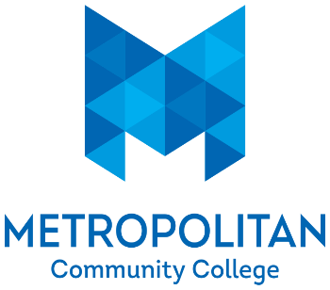
MCC Express
www.mccneb.edu
3002 South 24th Street, Omaha, NE 68108
(531) 622-4060
- Adult Education
- GED
- Computer Literacy

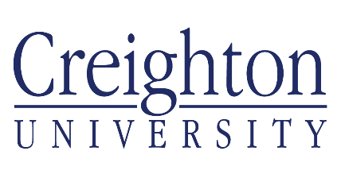
Creighton Educational Opportunity Center
www.creighton.edu/trio/educationalopportunitycenter
2002 Burt Street, Omaha, Nebraska 68178
(402) 280-3300
- Adult ESL
- Adult education
- GED

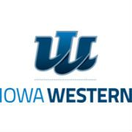
Iowa Western Community College
www.iwcc.edu/continuing_education/adult_education
2700 College RD, Council Bluffs, IA 51503
(712) 325-3256
- Adult ESL
- Adult Education
- HiSET (Iowa’s version of GED)
- Computer Literacy

OPS Multiple Pathways
www.multiplepathways.ops.org
3230 Burt ST, Omaha, NE 68131
(531) 299-9391
- Alternative routes towards an OPS high school diploma

Adult Education

In the United States, people are encouraged to become lifelong learners. If you are an adult in need of a high school diploma, there are programs available to assist you. These classes prepare you to earn the recognized equivalent of a high school diploma (such as a General Educational Development [GED] certificate). A GED certificate is the most well-known equivalent to a high school diploma, although some states may require that you take another test that is similar to the GED or meet other requirements in order to obtain a high school equivalency diploma or certificate. A high school equivalency diploma or certificate (such as a GED) shows that you have learned high school-level academic knowledge and skills. To earn a GED, you must pass tests in four different areas: reasoning through language arts (reading and writing), social studies, science, and mathematical reasoning. Most U.S. employers consider a GED credential to be equal to a regular high school diploma. In many areas, GED preparation classes are free or low cost.
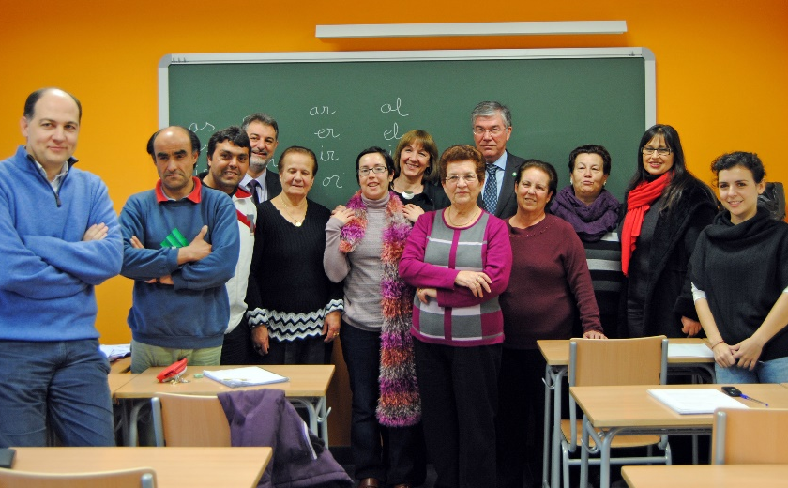
Additionally, many adults take classes to learn more about a subject that interests them or to learn new skills that can help them in their jobs. Local community colleges offer a wide range of adult education classes. Typically, these classes have low fees and anyone can enroll. Check with your local school system or community college to find out what classes are available, how much they cost, and how you can enroll.

Adult ESL Classes – Learn English
There are many places where you can learn how to speak, read, and write in English. These classes are also called ESL (English as a Second Language). These programs are usually free. ESL classes are available at different times and locations. To find the ESL program nearest to you, visit: https://omahalibrary.org/learn-english/
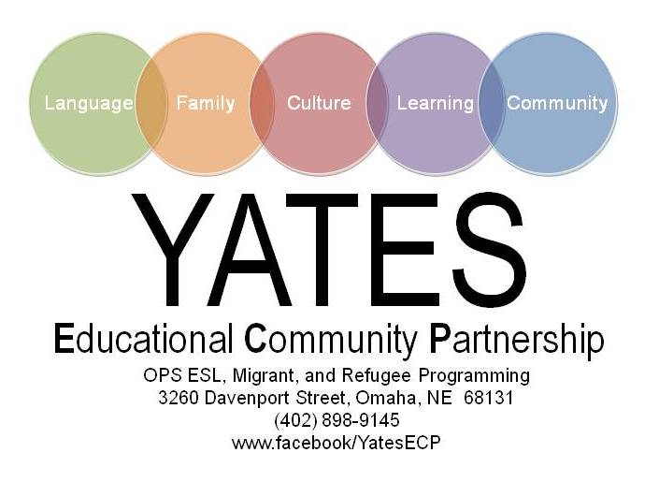
Or join Omaha Public School’s parent involvement program at Yates Community Center.
Yates Community Center offers five levels of English, citizenship class, cultural orientations, sewing, and gardening.
Classes are Monday-Friday 9:00am-12:00pm at 3260 Davenport Street.

Acknowledgement of Receipt

Please initial:

________ I have received information on the Omaha Public Schools credit requirements for high school graduation.

________ I understand high school graduation is dependent upon credits earned, not age or years in school.

________ I have been informed of alternative educational opportunities in case graduating from an OPS high school is not possible before I age out of the system.

____________________________________________________ ___________________
Signature of student Date

____________________________________________________ ___________________
Signature of guardian Date

____________________________________________________ ___________________
Signature of OPS staff providing information Date

