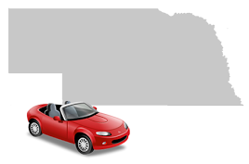
Never drive without a valid driver’s license and insurance.
Nebraska Driving Laws
Learners permit holders cannot drive without a licensed person in the car.
Drivers and front seat passengers must wear seat belts at all times.
Children under the age of 12 should always sit in the back seat of a car.
In Nebraska, children up to the age of 6 years old need to be in approved car seat.
Different states have different laws, so be careful when driving in another state to check their child safety laws.

It is illegal to leave a child age 6 years or younger unattended in a car in Nebraska. When left unattended, children are at risk of extreme temperatures, kidnapping, or tampering with the vehicle's gears or ignition.
Leaving a young child alone in the car could result in criminal charges, fines, and may impact immigration status.
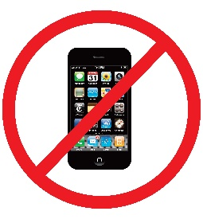
Cell phone use of any kind is banned for learners permit holders.
It is illegal for all drivers, regardless of age, to text while driving.

