Naming Conventions in Burma (Myanmar)
Naming conventions in Burma vary greatly from those of Western cultures. In the United States, people tend to follow the convention of [first name], [middle name], [family/surname]. This is not the case in Burma, which unfortunately leads to frequent misunderstandings during the immigration/refugee resettlement process.
There are no “first names” or surnames in Burma. Rather, people have one personal name. Similar to traditional Native American names in the United States, such as Crazy Horse or Sitting Bull, one would not split the name up when referring to a person, the name is said in its entirety. For example, one would not refer to Crazy Horse as “Crazy” alone as it completely changes the meaning and intent of the name. Crazy Horse is not from the ‘Horse’ family, Sitting Bull is not from the ‘Bull’ family – those names refer to those individuals alone.
Typically upon immigrating to the United States, refugees from Burma have their one personal name split up by syllables in order to match our systems. For example, a person named Ehlawsoe (“Love Forever”) becomes Eh [first name] Law [middle name] Soe [surname]. It would be unusual if all members of the family had the same “surname” under these naming conventions as there is not a cultural custom of passing down last names. The names of members of families often have no resemblance to each other. Additionally, because names have personal meaning, they may not be casually shared with strangers and nicknames are frequently utilized.
People from Burma may be confused by Western naming conventions. It is common for people from Burma to not know what is meant by ‘family name’ or ‘surname’ unless the concepts are explained clearly and adequately in a language spoken fluently by the person. It is also common for people from Burma to think of family in terms of their clan, or ethnic subset, as there is extremely strong emphasis on ethnicity/clan in Burma. There is no catch-all national identity in Myanmar; “Burmese” refers specifically to people of Burmese ethnicity from the Burman state. Chin people are from the Chin state, Karen are from the Karen state, etc. It is common for people to state what clan/region they come from when asked who they are.
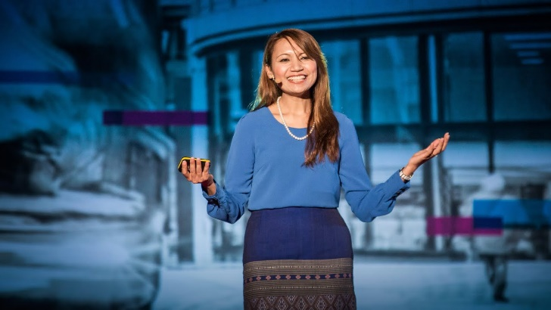
Watch this brief TEDtalk to learn more.
Ma Shwe Sin Win (Cynthia):
Not good with names:
Local name customs in a global village

www.youtube.com/watch?v=TffL_gKlSFE

