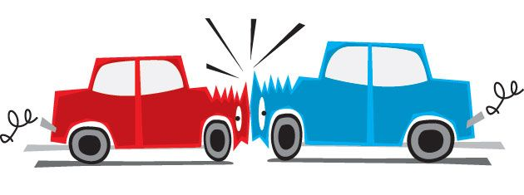
What to do in a Car Accident

1. Move to a safe area
If it's safe to do so, move your car out of further harm's way, like to the shoulder of the road.
If moving your car isn't possible, turn on the hazard lights to warn other drivers that your vehicle is stuck. Make sure it's safe to get out of your car before opening the door.

2. Check on others involved
Make sure no one is hurt. Call 911 if anyone may be injured. Even a seemingly minor symptom like dizziness should be checked out by a health care professional.

3. Call the police to the scene
Even in minor accidents a police report is important when dealing with your car insurance company and other drivers. Cooperate fully, but do not admit fault while at the scene.
Let the police objectively judge events and determine who, if anyone, is at fault in the crash.

4. Gather information
Try to write down as much info as possible in the accident aftermath, including:
- Driver and passenger names
- License plate numbers
- Other driver’s Insurance info
- Makes and models of all vehicles involved
- Contact info for any eyewitnesses
- Location of the accident
- The name and badge number of any responding police officers

5. Document the scene
If you have a phone with a camera, snap some photos of the accident scene.

6. File an insurance claim

