Tips for Parenting in the U.S.

Parent Rights and Responsibilities
In Nebraska, parents are legally responsible for their children until they reach the age of 19.
Parents are required to provide:
- Safe and sanitary housing
- Clean, weather appropriate clothing
- Food
- Medical care
- Ensure school attendance

As a parent in the United States, you have the right to set the rules in your own home. You determine the traditions, values, and behavior expectations for your children to follow. Your child may pressure you to change your rules by saying, “all my American friends do this” or “all the other kids have this”, but you do not owe your child any material item that isn’t necessary for their health and safety. It is your choice whether or not to give your children a cell phone or other electronics, at what age, and how much time per day they can spend playing with them.

As a parent, you have the responsibility to provide a safe, loving home for your child and make sure they attend school daily and on time. In Nebraska, children age 6-18 are legally required to attend school. This is not a choice. The parent will be held legally responsible for truancy and tardiness. It is the child’s responsibility to respect adults, follow the rules, and attend school. There are community resources available if you need help with a disrespectful or misbehaving child. Ask your child’s school staff for help, or call:
Nebraska Family Help Line: 1-888-866-8660
Trained Counselors 24 hours a day offering advice to parents in need

If your child is missing or in danger, call 911

What is Child Protective Services? (CPS)
CPS is the government agency that handles reports of child abuse. CPS provides a wide range of services to ensure the health, safety and well-being of children. Nebraska state law requires that when any person has reason to believe that a child may be abused or neglected, a report must be made to CPS or the police. A person does not have to have proof that the child is being abused, just a reasonable suspicion. If individuals fail to make a report, they are breaking the law. The identity of the person who made the report is confidential.
The phone number to report child abuse and neglect to CPS is 1-800-652-1999.

What is Child Abuse and Neglect?
There are different types of child abuse and neglect:
- Physical Abuse: an injury that is not consistent with the explanation given, or is non-accidental, or poses substantial risk of bodily injury; a physical act that results in injury to the child.
- Physical Neglect: the failure of a parent to provide basic needs or a safe and sanitary home for the child.
- Sexual Abuse: any sexually oriented contact or interaction in which the child is used for the sexual stimulation of a parent, the child, or other person.
- Emotional Abuse and Neglect: when the child suffers negative emotional effects due to a parent’s failure to provide feelings of being loved, wanted, secure, and worthy.

Different states may have slightly different definitions. Nebraska law defines child abuse and neglect as:
“Knowingly, intentionally, or negligently causing or permitting a minor child to be: (a) placed in a situation that endangers his or her life or physical or mental health; (b) cruelly confined or cruelly punished; (c) Deprived of necessary food, clothing, shelter, or care; (d) left unattended in a motor vehicle if such minor child is six years of age or younger; (e) sexually abused; or (f) sexually exploited by allowing, encouraging, or forcing such person to solicit for or engage in prostitution, debauchery, public indecency, or obscene or pornographic photography, films, or depictions.”

Child Supervision Guidelines
Preschool age children (age 6 or younger) should never be left alone or without adult supervision.
Nebraska does not have a law stating the specific age children can be left home alone. Each situation must be evaluated on a case by case basis considering a number of factors. Here is a guideline to help determine what is appropriate for your family:

Consider…
- Your child’s intelligence, maturity, and level of responsibility
- The length of time the child will be alone
- The circumstances under which they will be unsupervised
  - Is it day time or night time, is the home in a safe neighborhood?
- Availability of a responsible adult to assist in emergency
  - Is there a neighbor the child can go to, or can the parent come home quickly?
Safety Tips for Kids Home Alone:
- Memorize full name of parents, address, and telephone number
- Have emergency phone numbers written down in the home where child can access
- Parent should call the child to check in (video chat is even better)
- Teach your child how to lock windows and doors
- Teach children kitchen safety – what is/is not OK to use
- Ability of the child to seek assistance in emergency
  - Does the child know how to reach the parent or an adult who could respond?
- Child’s ability to act in an emergency
  - Does the child know how to exit the home in a fire, what to do if a stranger knocks on the door?
- Child’s feelings about being alone
  - Is he/she afraid or uncomfortable with the plan?
- Child’s ability to care for him/herself while alone
  - Can he/she fix a meal, entertain themselves?
- Can the child be trusted to follow household rules
  - Not having friends over, inappropriate internet use?
- Are dangerous things available to the child
  - Guns, drugs or chemicals?
- Is the child expected to supervise younger children

If the child is alone and someone calls CPS or the police, the responding officer will consider these factors to determine safety. If the officer determines that the child is not able to stay alone safely, it is possible the parent will get a ticket for child neglect.

Importance of Sleep
Kids need plenty of sleep to learn and grow properly. Be sure your child gets enough sleep. Tired kids are difficult kids.
Stop “screen time” (phone, tablet, TV, computer) at least an hour before bedtime.
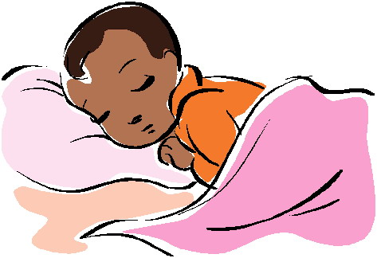
Here is how much sleep people need based upon age:

Age of Child | Hours of Sleep Needed Per Day
1-3 years | 12-15 hours
3-5 years | 11-13 hours
5-12 years | 9-11 hours
12-19 years | 9-10 hours
Adults | 7-8 hours

Positive Reinforcement
Regardless of age, “positive reinforcement” is an effective parenting strategy. Positive reinforcement is when you acknowledge good behavior and encourage your child to stay on a positive track. Make sure your child knows you see and appreciate their good choices. Thanking a child and telling them you are proud when they do something good is the best way to get them to repeat positive behavior.

Parenting Goals

Age of Child | What should I be training my child? | What are my parenting objectives?
0-5 years | Training for obedience (obey your parents) | Establish authority as a parent
6-12 years | Training for virtue (good behavior) | Shape child’s character
13-18 years | Training for responsibility (be an adult) | Build child’s responsibility

Can I physically discipline my child?
Parents are allowed to physically discipline their children, but only within specific guidelines:
- You may use an open, empty hand to spank your child.
- You cannot use a fist.
- You cannot use a tool of any kind. No sticks, belts, shoes, spoons – nothing, no matter the size.
- You cannot hit so hard as to leave a lasting mark, cut, or bruise.
YES:
NO:

It is not wise to spank in anger. If you are calm, you are better able to control yourself. Even though spanking is legal in the United States if you follow the guidelines, it is not always age appropriate or effective. Generally, spanking is more effective for children under 5 years old. Older children to not often respond well to spanking. In order to determine the most effective discipline method for your child, consider their age and personality. What motivates your child? Are they relationship motivated, motivated by reward, motivated by certain activities? If you have more than one child, they may have different personalities and therefore different methods may be required to discipline most effectively.

Alternatives to Physical Punishment
Time-Out: Ages 1-7 years. 1 minute per year of age sitting quietly by themselves. Do not let the child get up or talk to anyone during their time-out. When the time-out is finished, calmly ask the child if they can explain what they did wrong and why it was bad. Explain what they should have done instead. Some children may need a hug when finished as reassurance the parent still loves them.

Grounding: Ages 8-18 years. Grounding is when you do not allow your child to leave home except for school, work, or church for a set amount of time (small misbehavior = short grounding period, like one weekend; major behavior problem = longer grounding period, like two weeks).
Taking Away Privileges: Ages 5-18 years. Having a phone, using the computer, and driving a car are all examples of privileges. Children do not NEED to do any of these things – you are providing extra privileges. You can take non-essential items away if a child intentionally breaks your rules. You can even require that they earn them back by doing something helpful for the family.
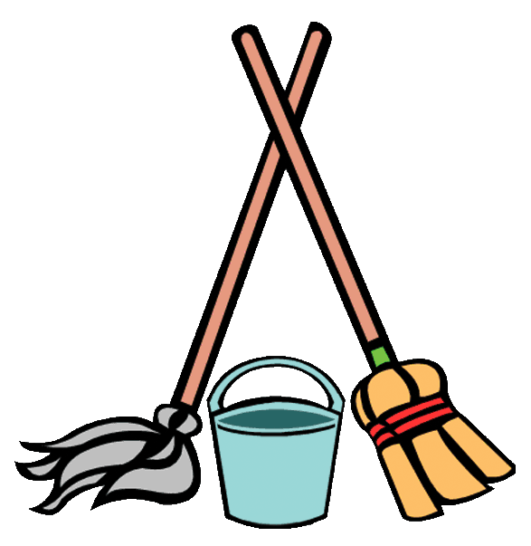
Extra Chores: In the United States, most families expect everyone to help around the home, not just females. If your child misbehaves, you can assign them extra chores around the home as punishment. Washing all of the dishes for a week; mowing the lawn, cleaning out the car are all examples of extra work you can make your child do if they intentionally break your rules.

Rules and Behavior Expectations in Your Home
State your rules clearly and specifically. Make sure your children know what your expectations are. It is a good idea to write up your most important rules and hang them somewhere in the home all family members can see (example for teens below). Don’t speak in general terms like, “be good today.” Set specific curfews, bed times, screen time, etc. This sets your child up for success. It is easier for them to follow rules when they know what the rules are.

Set clear consequences. Consistency is the key to discipline. Your children need to know you are the boss and that you won’t be pushed over easily. Rules and consequences are for a child’s long term betterment. This will help the child understand the link between negative behavior and consequences.

Follow through every time! If you don’t follow through with consequences consistently, children will not develop respect for rules. Parents should try to remain calm when punishing a child. Explain to your child what rule they broke, why that rule is important, and what the positive choice they should have made instead. Do not waiver on the consequence. Remember that you are their parent, not their friend.

Be a good role model. Behave the way you want your child to behave. No matter what we say or how many times we say it, our children will do as we do.

Here is an example of a “House Rules” poster for older children:

House Rules | Consequence if Broken
No more than 2 hours of screen time (TV, computer, tablet) per day | Screen privileges revoked for ___ days
Always tell parent where you are going; provide the phone number of the friend’s parent | Grounded for ___ days  Cell phone privileges revoked for ___ days
Home by 6:00pm for family dinner | If you are late without calling to give a valid reason, you will cook and clean up dinner for the family for one week
Bedtime is 10:00pm (no screens by 9:00pm) | No excuses or arguments

Your house rules and consequences may look different. The key is to have house rules and consequences clearly stated.
Chore Charts are another good idea. It is everyone’s responsibility to keep the home clean and organized.
Here is a sample Chore Chart:
(Child’s Name) | Monday | Tuesday | Wednesday | Thursday | Friday
Wash Dishes
Clean Bathroom
Laundry
Sweep and Mop
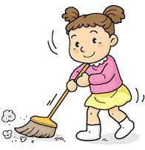
Cook

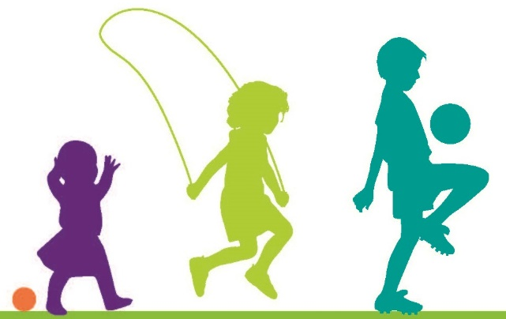
Parenting Tips for Younger Children

2 years old: Handle tantrums with care. Don't give in to a tantrum, but remain close by until it stops. You may need to remove the child from the situation to help them calm down. Then direct your child toward positive behavior; show them what the better way to behave looks like.

3 years old: Have your child help with tasks. Rehearse good behavior. Play games to practice routines. For example, play a song and have your child try to finish three tasks before the music stops.

4 years old: Have the consequence fit the crime – if he makes a mess, he helps clean it up. Handle lies and cheating calmly. Such behavior is normal at this age. Don't shame your child or dwell on whether he did or did not do something. For example, if he spills a glass of milk, say, "Those cups can be hard to handle so we have to be very careful." Then have him help you clean up. He'll feel understood and less fearful of telling the truth in the future.

5-7 years old: Young kids are visual learners, so keeping a behavior chart can be helpful. For example, each morning put a sheet of paper with three smiley faces on the refrigerator. Cross out one face per misbehavior. If your child can get through the day with at least one smiley face left, reward her with a sticker for each.
X
John Doe’s Day

Use limits to emphasize self-control. For example, set a timer on your phone and say, "You have two minutes to stop crying or you'll get a time-out."

Use praise to reward helpfulness. Have your child help with chores so he can feel good about pitching in. This will build self-esteem. In general, reinforce good behavior.

8-10 years old: Talk about what happened and why. 8-10 year-olds respond well to having options. For example, if your child is cutting corners on homework because she's too busy, let her pick which activities to drop. She'll learn that life is about making choices and that privileges are earned by good behavior. Emphasize natural consequences and making amends. If your child doesn't put her dirty clothes in the right place, don't wash them. If she loses her friend's toy, have her replace it. If she's hurtful to a classmate, insist she apologize. This will reinforce values and help her develop a sense of responsibility.

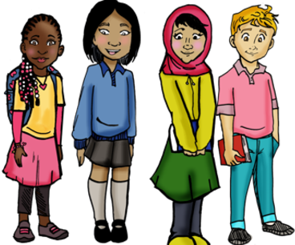
Parenting Tips for Older Children
Make your limits clear. Certain behaviors are nonnegotiable and let your child know that. You may not like him to go out without an adult to supervise. Be clear and consistent with your limits so there are no misunderstandings.

Set clear guidelines and behavior expectations as well as clear consequences. Your child needs to understand your expectations.
A visual behavior chart can be helpful. For example, if your preteen consistently argues with you, set up a behavior chart that targets disrespectful talk. Remove privileges for backtalk, reward when if they make an effort to stop. Instead of telling your child in generic terms that he is "behaving badly and needs to improve", lay out each behavior specifically that you would like him to work on.
Here is a sample Behavior Chart:

(Child’s Name) |  | Respectful to Parents | Kind to Siblings | Obeys Requests | Helps Keep Home Clean
Monday | Good | X |  | X
 | Needs to Improve |  | X |  | X
Tuesday | Good
 | Needs to Improve
Wednesday | Good
 | Needs to Improve
Thursday | Good
 | Needs to Improve
Friday | Good
 | Needs to Improve

Hang the behavior chart somewhere that is easy for you and your child to see. Mark when they are meeting your behavior expectations and reward it. Special outings or activities together are a good reward – try to avoid giving money or material items, unless there is something special they would like to save up “positive points” and earn through long-term good behavior.

If the negative behaviors outnumber the positives by the end of the day or the end of the week, follow through with appropriate consequences.

Most Importantly!
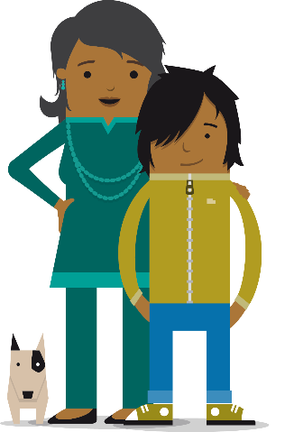
Schedule one-on-one time with your children regularly.
Tell them what you appreciate about them. Point out their strengths. Listen to their opinions. Find out what interests them. Find out who their friends are and how they feel about school and if they have dreams for their future.

Explain family values and share cultural traditions.
Talk to your children about your home culture through stories. Teach them their history. Instill pride in who they are and where they come from.

Get to know the parents of their friends.
Communicate with the other parents to make sure your child is telling the truth, that the friend’s home is a safe place to be, and that it’s OK with the other parent for your child to be there. Your child’s safety is more important than embarrassment or being overly polite. Parents need to work together and support each other to ensure youth grow up to be safe and respectful members of society. Raising children in a new culture is hard – we all need to help each other.

ESL, Refugee, and Migrant Programs 2018

